|  |
| --- |
| **Technology Architecture Document**  Jamf Onboarding  Date: 11/08/2025  Status: v0.1 Draft  Author: Russell Collis |

Contents

1 Document Controls 3

1.1 Document Version History 3

1.2 Document Owners 3

2 Jamf Setup Manager 4

2.1 Business 4

2.2 Application 4

3 Onboarding Steps 5

3.1 Pre Jamf Setup Manager (JSM) 5

3.2 Jamf Setup Manager 10

3.3 Continued macOS Setup 14

3.4 Final Setup 16

3.5 Overview 23

# Document Controls

## Document Version History

|  |  |  |  |
| --- | --- | --- | --- |
| **Date** | Version | Author | Revision |
| 11/08/2025 | V0.1 | Russell Collis | Draft |

## Document Owners

|  |  |  |
| --- | --- | --- |
| **Name** | **Title** | **Responsibility** |
| Russell Collis | Senior Mac Specialist | Solution Architect / Product Owner |
|  |  |  |
|  |  |  |
|  |  |  |
|  |  |  |

# Jamf Setup Manager

## Business

### Business Use Case

Jamf Setup Manager is primarily used by organisations to streamline and automate the initial configuration of Apple devices (Mac, iPhone, iPad) for employees. Here are the key business use cases:

**Zero-Touch Deployment** Organisations can configure devices before employees even receive them. When a new starter opens their company MacBook or iPhone, it automatically connects to corporate systems, installs required apps, and applies security policies without IT intervention.

**Cost and Time Savings** Instead of IT staff manually setting up each device (which can take hours), Setup Manager automates the entire process. This is especially valuable for companies onboarding many employees or managing large device fleets.

**Security and Compliance** Devices are automatically enrolled in Mobile Device Management (MDM), ensuring security policies are applied from day one. This includes encryption requirements, password policies, VPN configurations, and restricted app installations.

**Consistent User Experience** Every employee gets an identical, properly configured device regardless of location. This reduces support tickets and ensures everyone has access to the same corporate resources and applications.

**Remote Work Enablement** Particularly valuable for distributed teams - devices can be posted directly to remote employees' homes and will self-configure when powered on, without requiring on-site IT support.

**Scalability** Essential for growing businesses or those with seasonal recruitment. Setup Manager handles bulk device provisioning without proportionally increasing IT workload.

The ROI typically comes from reduced IT labour costs, faster employee productivity, and improved security posture across the organisation's Apple device ecosystem.

## Application

*https://www.jamf.com/blog/apple-device-enrollment-jamf-setup-manager/*

# Onboarding Steps

## Pre Jamf Setup Manager (JSM)

Step 1 – Select County or Region

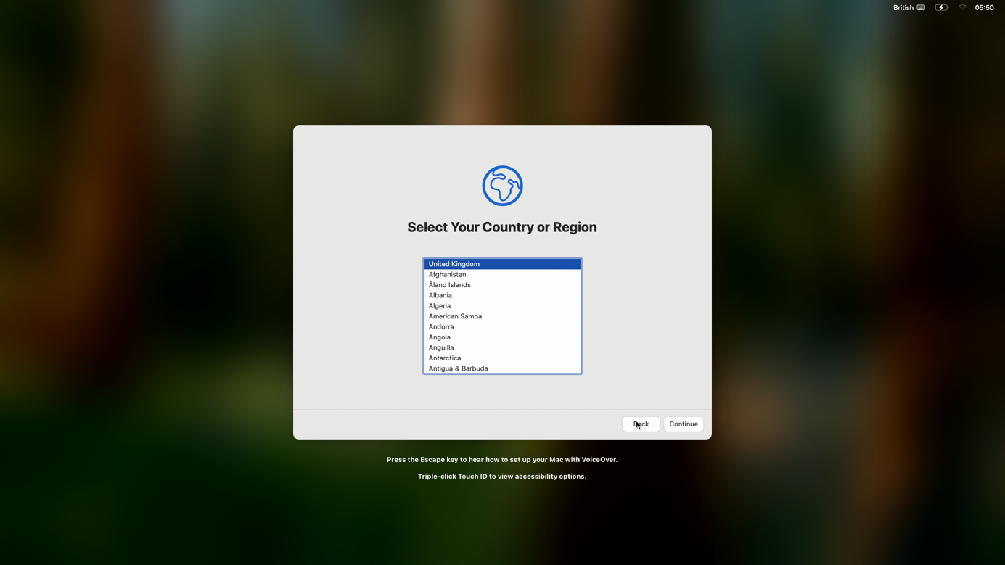

Step 2 – Setup as New Mac

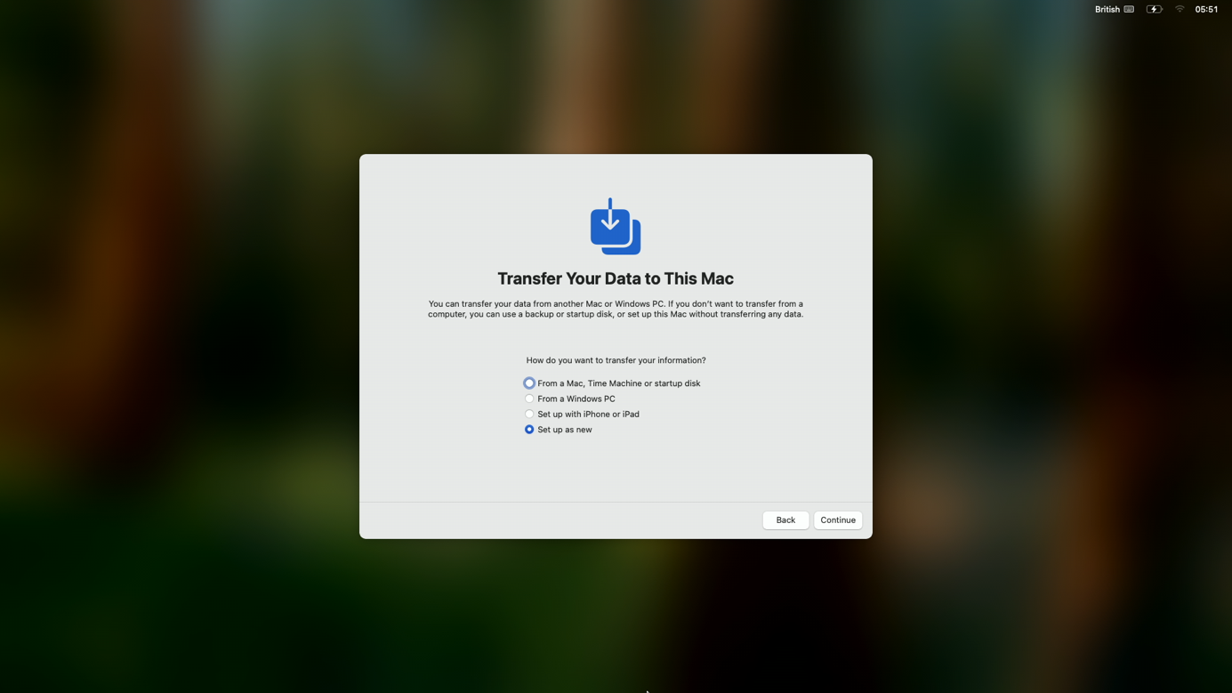

Step 3 – Confirm Accessibility Settings

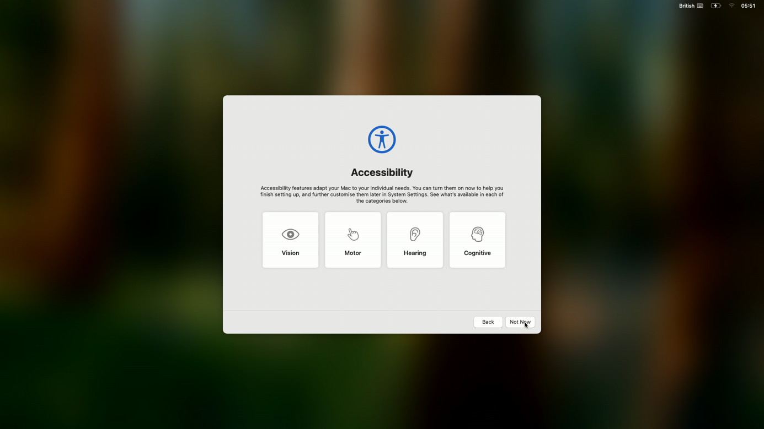

Step 4 – Connect to wireless network

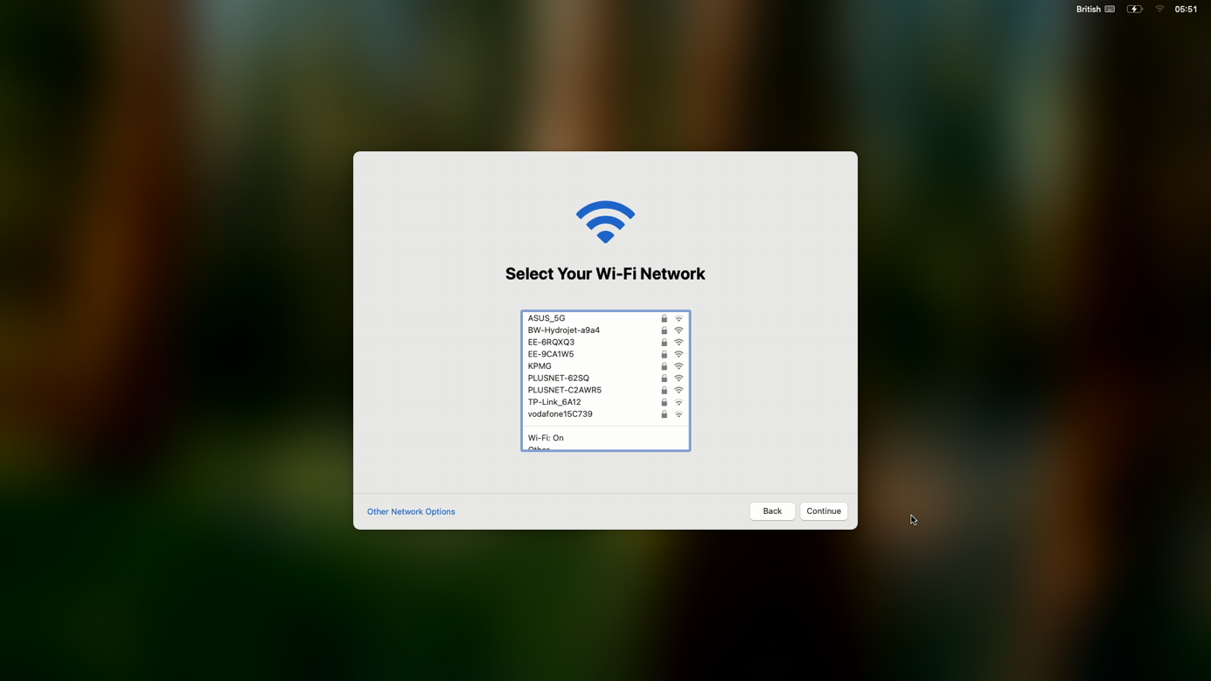

Step 5 – Click ‘Enrol’ for Remote Management

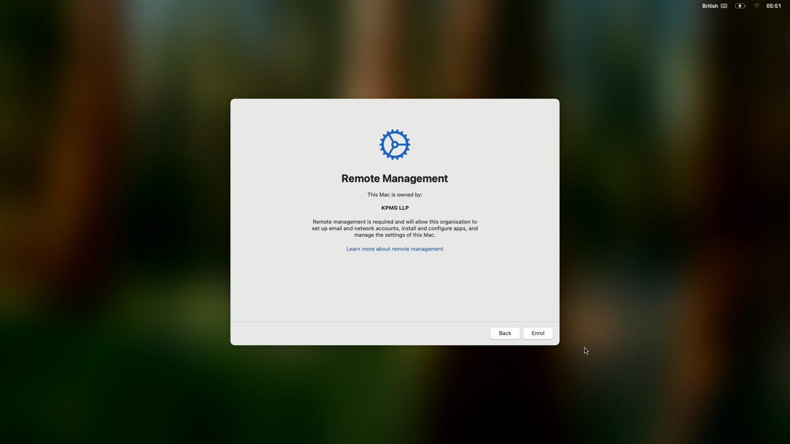

Step 6 – Sign in with KPMG email address

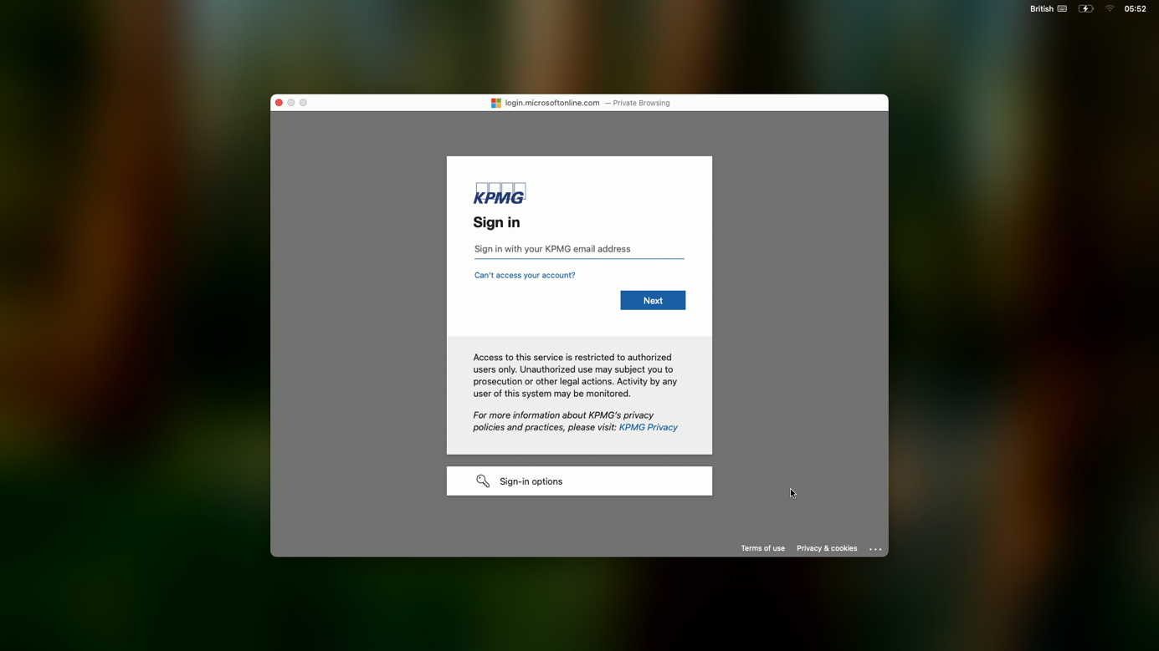

Step 7 – Enter password

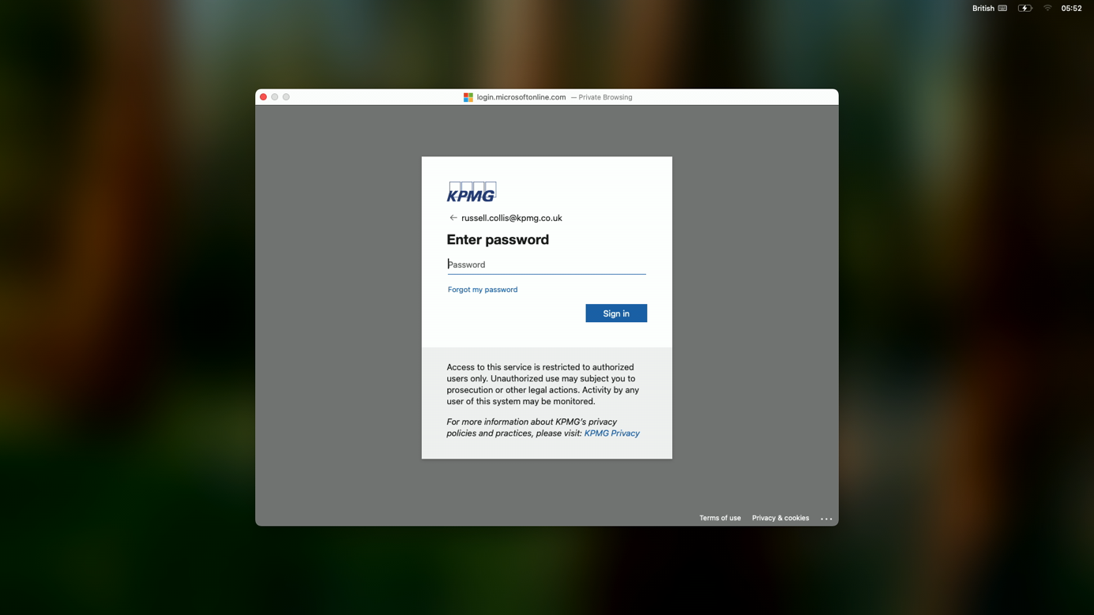

Step 8 – Confirm with 2FA



Step 9 – Remote managemtn begins

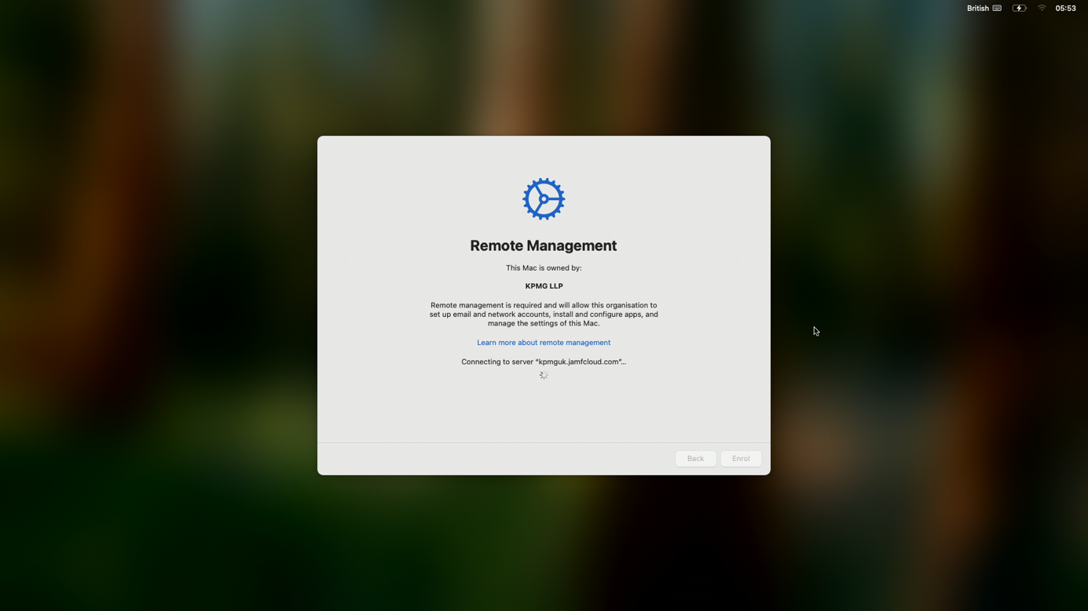

## Jamf Setup Manager

Step 10 – Enter Asset Tag



##### NOTE:

The asset tag is a 6 digit number preceeded by a capital K – there is validation on the input to ensure K followed by 6 digits are entered.  
  
Once entered correctly click ‘Save’

Step 11 – Finish

Once Jamf Setup manager has installed the applications – click ‘Finish’

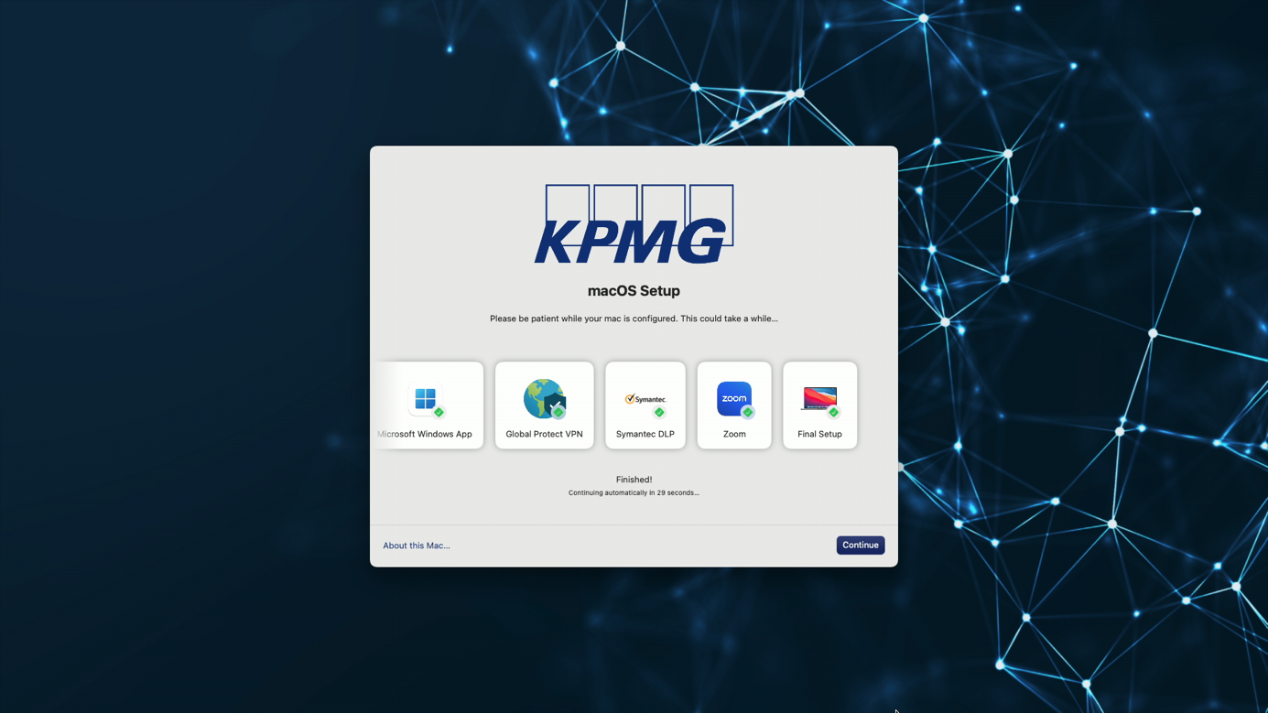

##### NOTE: This should atke around 30 minutes on a standard 40mb conneection

### Mac Info

Click about this mac for information on the mac

Hold ⌥ (Option) to get extended details

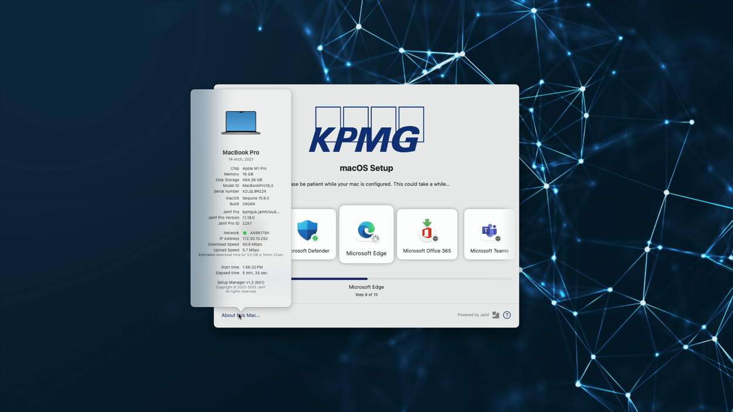

### Help

Click the ? for details on support during the enrolment

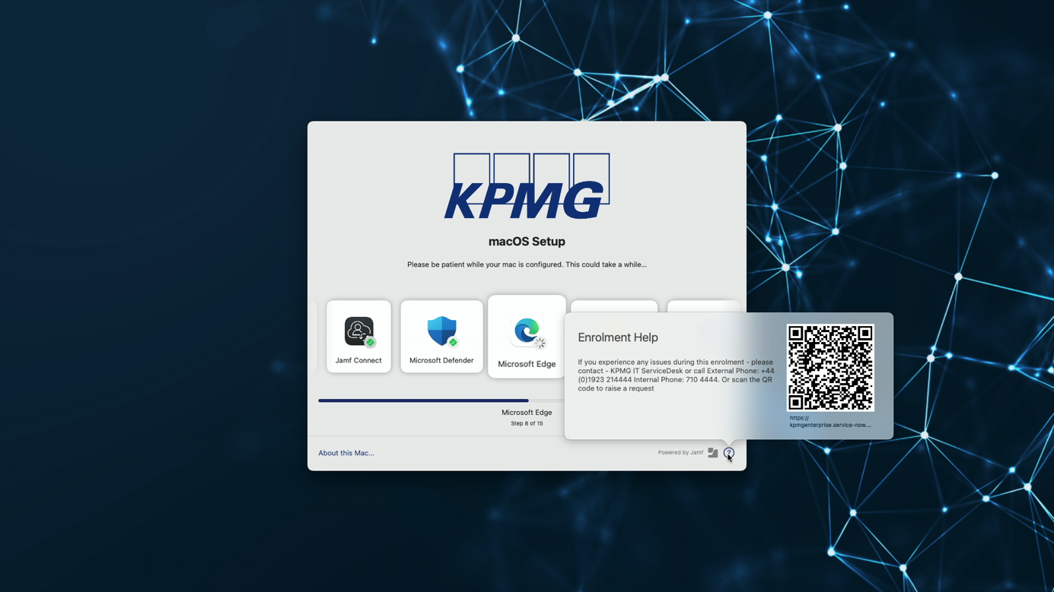

### Logging

Hold ⌘+ L to open the logging panel

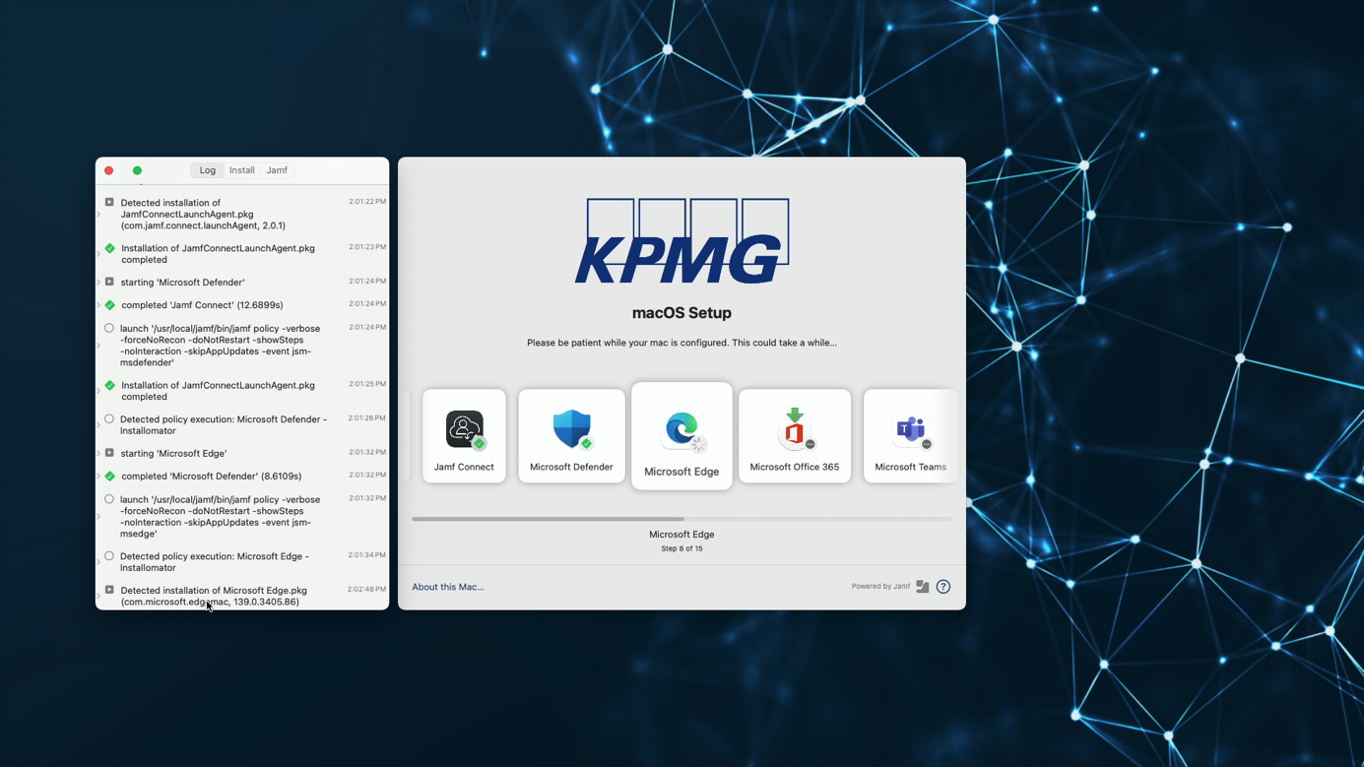

## Continued macOS Setup

Step 12 – Create account password

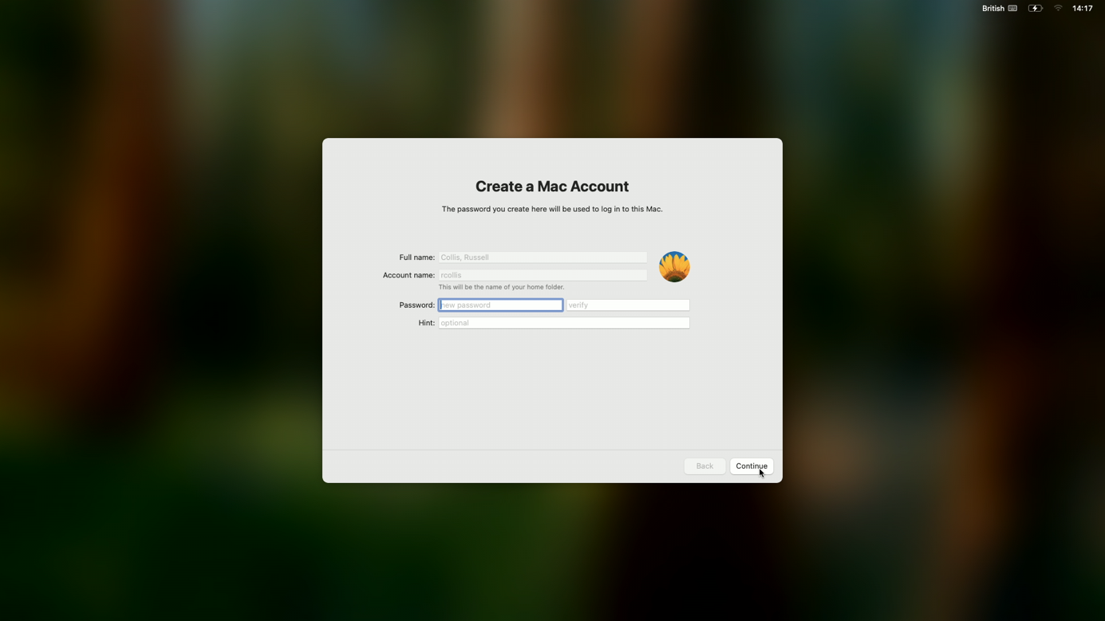

Step 13 – Enable Location Services

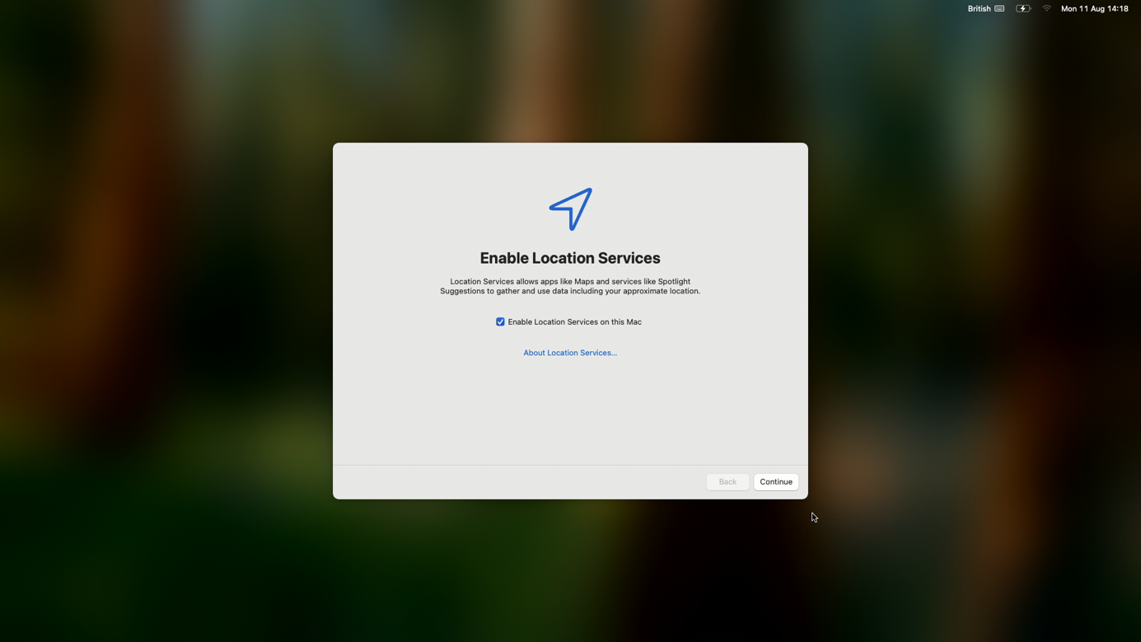

Step 14 – Setup Touch ID

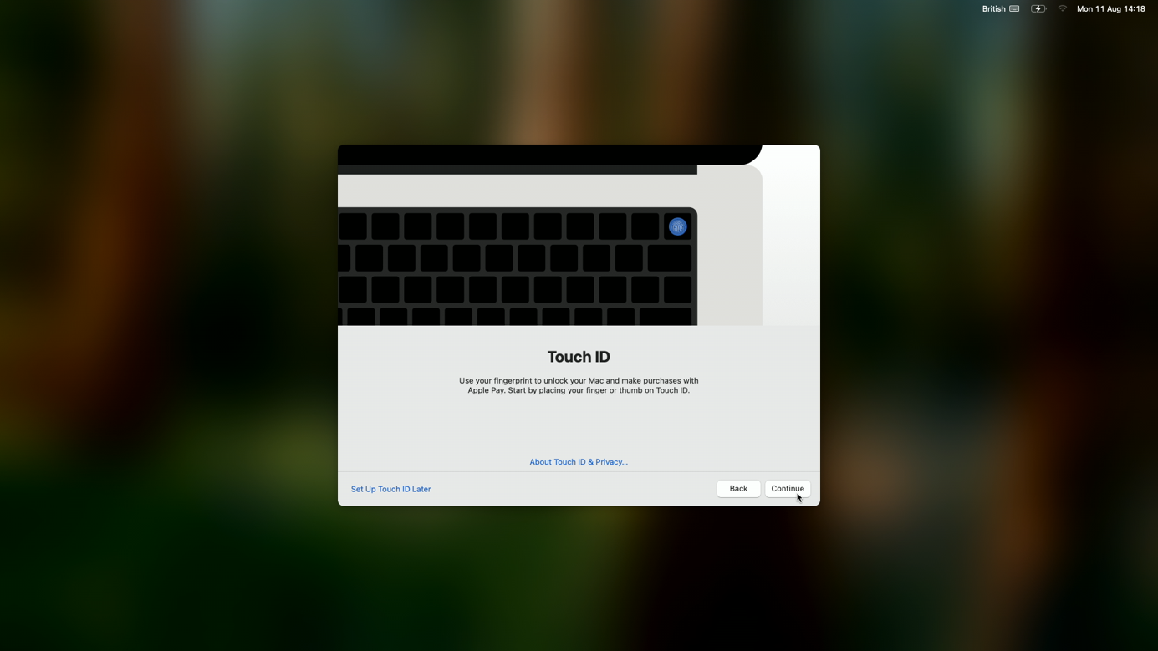

## Final Setup

Finally when macOS lands on trhe user desktop – a saetup message appears

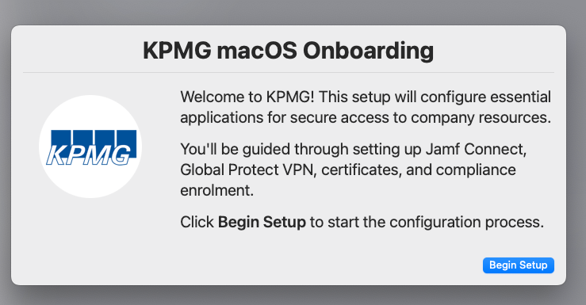

Step 15 – Jamf Connect

Enter useranem (email) and password as prompted   
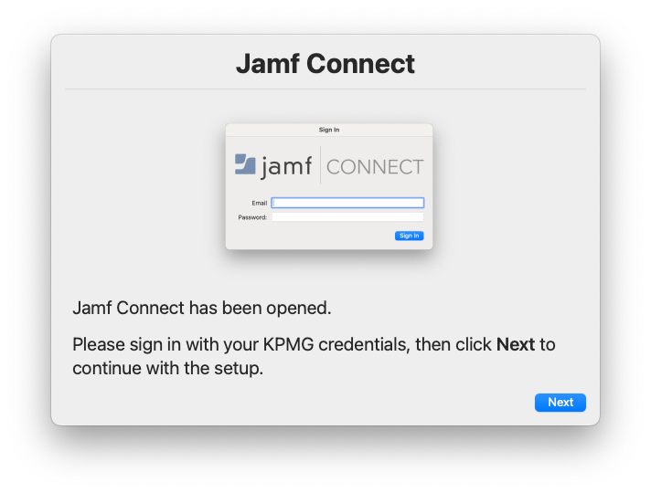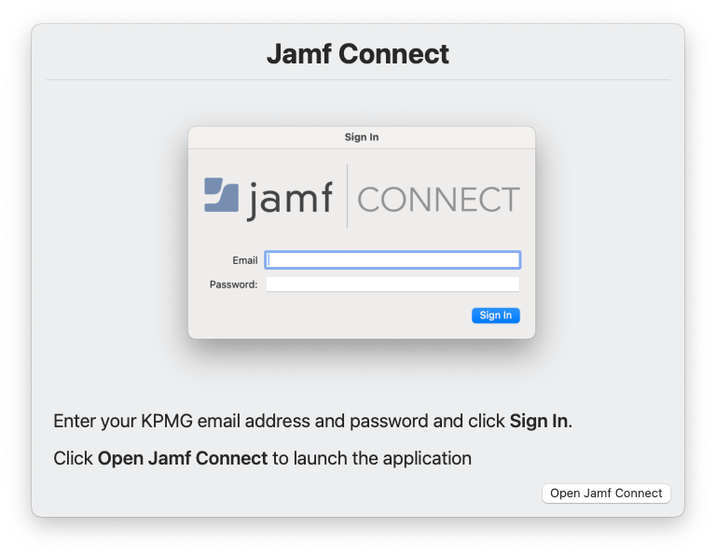

Step 16 – Global Protect  
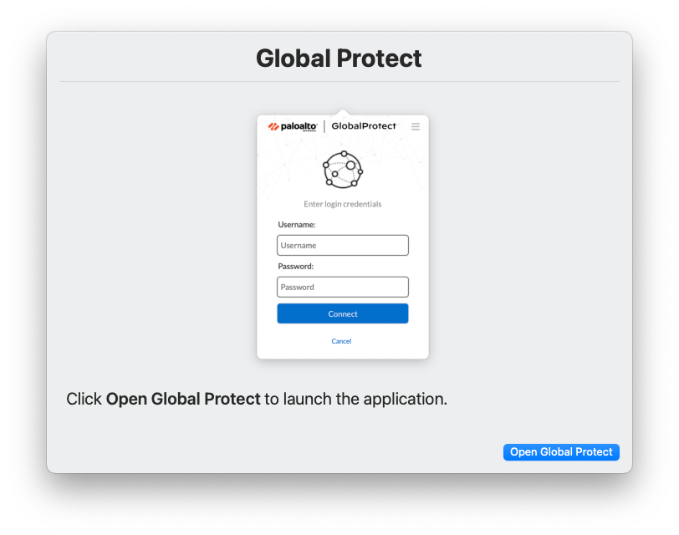

Sign into Global Protect with username and password

##### NOTE: This is your shortform windows AD username

*For example*

*Name – John Smith*

*Email – John.Smith@KPMG.co.uk*

*Username: jsmith*

##### You will be given these details during general onboarding

Step 17 – Certificates

Enter your mac password and click ‘Always Allow’

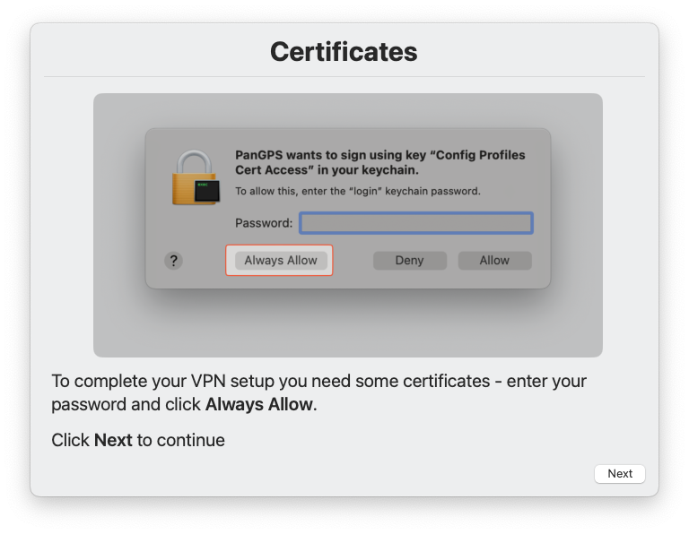

Step 18 – Compliance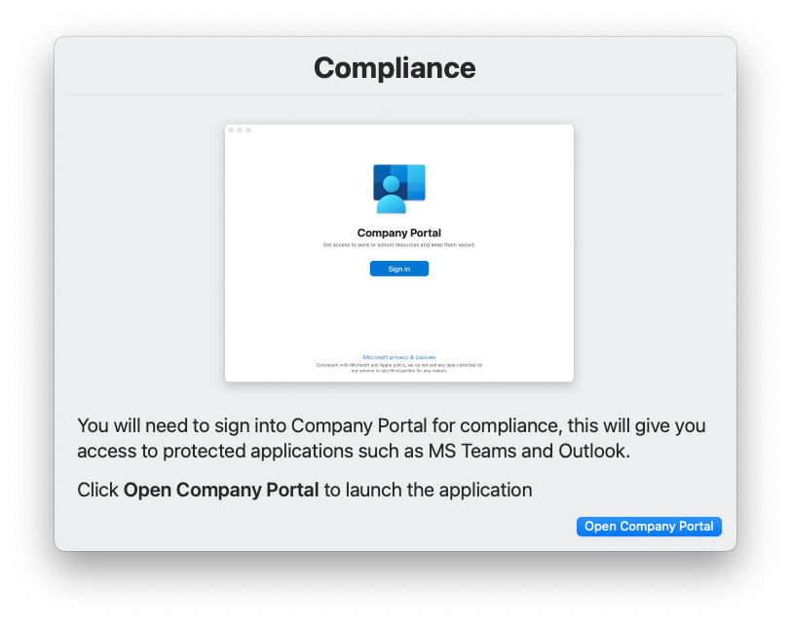

Opening company portal will prompt you to approve the cerificates – if Touch ID is setup – use this to confirm, otherwise your mac password.

Step 19 – Certificate Approval

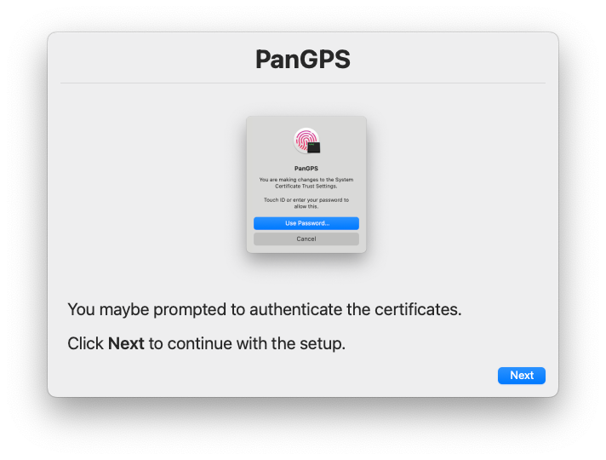

Step 20 – Complete

Finally sign into Company portal to complete compliance and get access to Microsft Outlook, Microsoft Teams and any other protected applications

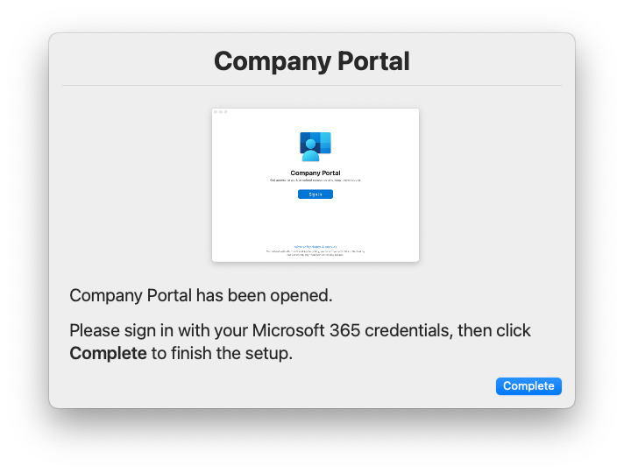

Once Completed – a core dock will also be loaded



## Overview

##### Note: Screens or wording may vary